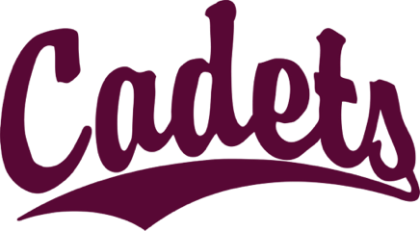

Cadet Youth Football Sponsorship Form

The mission of the Cadet Youth Football League is to bring area youth together to learn the game of football, have fun, and gain life-long lessons in teamwork, sportsmanship, competition, and hard work. The league is supported by knowledgeable coaches and administrators, with an emphasis on teaching, learning, growing, and developing area youth so they can participate in and enjoy the game of football in an organized and safe environment.

Sponsorship Levels

Platinum - $1,000
Includes name/logo on website and sign that will be at Concordia Zollner Stadium throughout the season. Includes name/logo on jumbotron at Concordia Zollner Stadium for all football and soccer games.
Incudes individual social media recognition.

Gold - $500
Includes name/logo on website and sign that will be at Concordia Zollner Stadium throughout the season. Includes name/logo on jumbotron at Concordia Zollner Stadium for all football and soccer games.
Incudes group social media recognition.

Silver - $250
Includes name/logo on sign that will be at Concordia Zollner Stadium throughout the season.
Incudes group social media recognition.

Bronze - $100
Donation only

Cadet Youth Football Sponsorship Form

Company Name:

Contact Name:

Website:

Phone Number:

Email Address:

Sponsorship Level Commitment (please check one):

Platinum Gold Silver Bronze

*Please email us your company logo.

Please make checks payable to Cadet Youth Football.

Questions? Contact Adam Corner at adamcorndog@gmail.com or Dale Doerffler at daledoerffler@gmail.com

Visit cadetyouthfootball.com for more information

